Grant Application for
Emerging Leaders COACHING PROGRAM
SUMMER/FALL 2025

Introduction
Since its founding in 1995, Community Memorial Foundation (CMF) has been dedicated to improving the health of people who live and work in the western suburbs. Healthy communities need healthy organizations, and every organization relies on strong and capable leadership to support its mission and growth. For this reason, CMF is proud to sponsor a professional coaching program for emerging leaders.
Community Memorial Foundation will provide funding so that emerging leaders can receive the support of a professional coach. Any staff member (non-executive directors/ CEOs) from organizations that have received a program grant from Community Memorial Foundation in the past five years are eligible to apply. Leaders interested in participating in this program must complete a coaching application. In 2025, CMF is sponsoring two cohorts (one in the Winter/Spring and one in the Summer/Fall. In each cohort, ten emerging leaders will be selected. Participants will complete several assessments and meet with a coach via Zoom over the course of eight months.
What is Professional Coaching?
Coaching is intended to help strong leaders take the next step in their development. Coaching helps leaders candidly reflect on their goals and what they hope to achieve in their organizations. A coach focuses on helping a leader "learn what it takes" to improve existing capabilities, set meaningful goals, and be accountable for results. A coach helps a leader understand and eliminate barriers to more effective performance. The idea behind working with a coach is to bring clarity to an issue and develop a plan of action for tackling it. Coaching is a tool that can help successful leaders become even better.
Coaching is not consulting. It is not about someone from the outside coming in with answers to an organization’s problems. Rather, a coach is a “thinking partner,” someone who can provide support and guidance and bring depth and focus to particular challenges faced by a leader. Coaching is relationship-driven and based on the trust and respect built between the coach and the client. The coach provides an objective point of view and empowers an individual to make more informed decisions relating to their development as a non-profit leader. Often, this involves assistance with strategic thinking, problem solving, and/or exploration of additional resources or approaches.
Program Direction
Direction and technical assistance for the Emerging Leader Coaching Program are provided by the Center for Creative Leadership (CCL).
The Center for Creative Leadership focuses on leadership education, research and expertise in solving the leadership challenges of individuals and organizations.
The Coaching Framework
Built on a time-tested model of adult development, CCL’s coaching framework incorporates three key components that are necessary for results: Assess, Challenge, and Support.

CCL’s Coaching Framework
- Listening to Understand: In order to understand the leader’s beliefs, vision, and desired future state, coaches go beyond active listening (repeating back, understanding, summarizing) to derive three different perspectives: facts, emotions and values.
- Asking Powerful Questions: Leaders will be asked courageous questions that drive their advancement and provoke new insights.
- Challenging and Supporting: Ultimately, coaching is about encouraging the leaders to try something different or to create a significant shift in perspective. This will be done in a safe and supportive environment.
- Establishing next steps and accountability: Having an effective conversation is only one aspect of successful coaching. The real work happens in between coaching meetings, where the leaders will apply insights and experiment with new behaviors.

Professional Coaching Logistics
Selected leaders will be matched with one of CCL’s 600 screened and vetted executive coaches. CCL will match leaders to coaches based on an intake completed by the leader. All coaching sessions will be held via Zoom. CMF staff will convene a kickoff meeting on August 15th at 2:00 PM to launch the program.
CCL’s Approach to Coaching: CCL’s Participant Coaching Journey involves a three-step approach—preparing for the coaching experience; engaging in self-reflection and learning; and applying lessons learned through coaching and other developmental work.
- Prepare
- Coach Selection: Leader is matched by CCL with their coach based on intake data.
- Orientation Meeting: The coach and leader will engage in a one-hour meeting to discuss ways of working together, cover logistics, and establish the initial goals for coaching.
- Assessments: The leader will begin completing 360 feedback and psychometric assessments designed to enhance self-knowledge and awareness. Assessments will include:
  - Benchmarks for Managers™: a comprehensive 360-degree assessment for middle-to upper-level managers that measures 16 competencies critical for success, as well as 5 possible career derailers.
  - The FIRO-B® Instrument: a self-assessment of an individual’s interpersonal needs and the impact of their behavior in the workplace. The assessment helps participants increase productivity through awareness of interpersonal dynamics at work.
  - The WorkPlace Big Five Profile™4.0: a trait-based, self-assessment used to explain work-related behaviors found in day-to-day encounters with co-workers, employees, managers, and colleagues.
- Engage
- Debrief & Goal Planning: The leader’s completed assessment results will provide key insights. Together with the coach, the leader will use those insights and create an action plan for the rest of the leader’s coaching journey to achieve the leader’s goals. This will include:
- 2-hour assessment debrief session
- 1-hour Goal Planning Session
- Alignment session with the leader’s manager enabling mutual feedback, challenge and support.
- Apply
- Developmental Coaching: During zoom-based 1:1 coaching sessions, the leader will discuss wins and potential obstacles. But the real learning takes place in between sessions, where the leader will practice new actions and behaviors. Leaders will have a total of 11 flexible hours with their coach over 8 months. These hours can be used for:
  - 1:1 Coaching
  - Stakeholder Interviews
  - Manager Alignment
  - Professional Development

- Measuring Impact: The leader and coach will establish key indicators for the leader’s ongoing success, which may include feedback from the manager, or surveys during and after the coaching engagement.
After the leader has been selected, the frequency and timing of all assessments and coaching sessions will be coordinated by CCL and will be mutually determined between the coach and leader without involvement from the Foundation.
Applicant Eligibility Criteria
Middle managers eligible for grant funding under this program need to:
- Be a staff member (not an executive director or CEO) at an organization that has received a grant from Community Memorial Foundation within the past five years;
- Be a leader in an organization that has demonstrated a service impact that reaches people from one or more of CMF’s target communities; and
- Receive the support of their executive director/CEO (and supervisor if someone other than Executive Director/CEO) to actively participate in the coaching program.
Selection Criteria
Up to ten leaders will be selected for the program. Because CMF typically receives more applications than can be approved, grantees will be chosen based on their commitment to actively participate in the coaching process and the emerging leader’s potential to be a catalyst for positive change in their organization and in the region.
The following criteria will be used to select the organizations:
- Dedication to improving the health of people who live and work in the 27 communities served by CMF.
- Strong leadership—this opportunity is best suited for strong leaders who deeply want to become even better.
- Open to change—strong candidates will be self-reflective, willing to learn, and open to new ideas.
- Commitment to implementing what is learned through coaching to strengthen their organization.
- Commitment to a shared vision for a more equitable and inclusive region.
- Only one staff member from an organization can apply for Coaching in each cohort; preference will be given to applicants from organizations with staff not currently engaged in a coaching relationship from a previous cohort of this program.

Deadline
Applications must be received at CMF by 5:00 PM, July 15th (no exceptions).
Timeline
- June 25th (2:00 PM) Informational meeting regarding Emerging Leader Coaching Program (held via Zoom)
- July 15th at 5:00 PM — Deadline for proposal submission
- By July 30th — Leaders selected for Emerging Leader Coaching Program
- August 15th (2:00 PM)— Kickoff meeting with selected leaders and CCL (via Zoom)
- By August 22nd — Assessments and coaching activities begin
TO SUBMIT YOUR APPLICATION:
◆ EMAIL the materials to tfuechtmann@cmfdn.org or
◆ SEND the completed application with attachments to:
Community Memorial Foundation
Attention: Tom Fuechtmann
15 Spinning Wheel Rd., Suite 326
Hinsdale, IL 60546
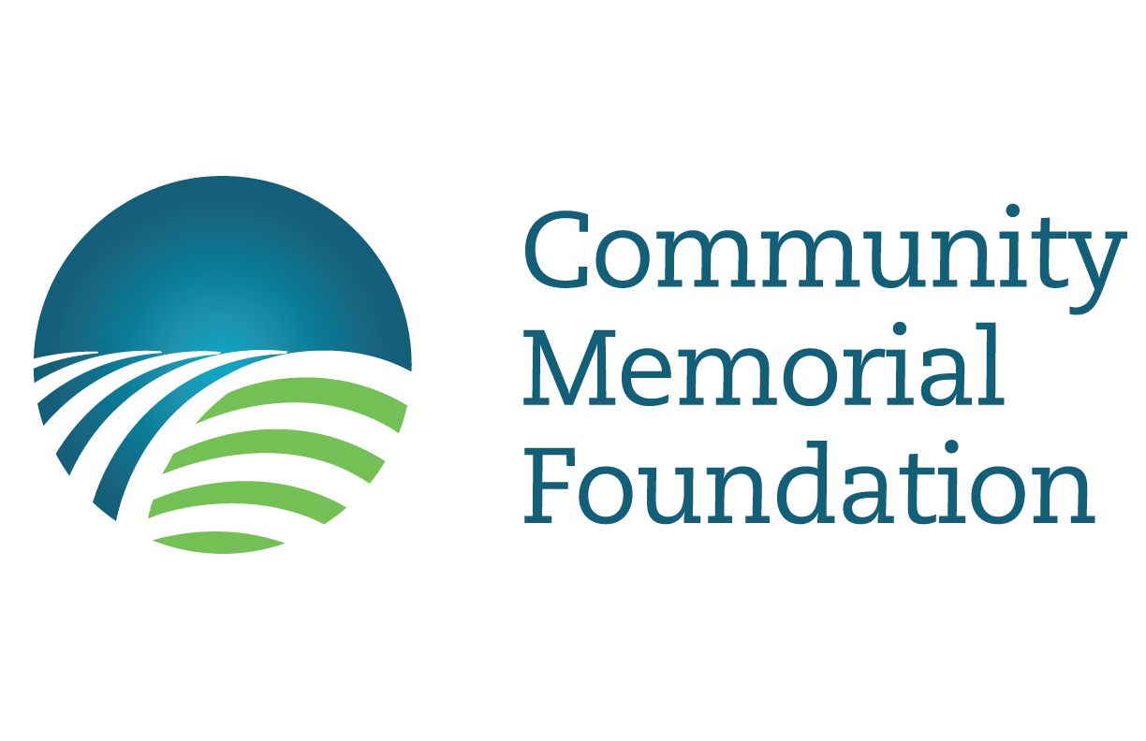
Community Memorial Foundation
Emerging LeaderCOACHING PROGRAM
GRANT Application Form

NAME:

ORGANIZATION:

POSITION:

PREFERRED PHONE NUMBER:

EMAIL ADDRESS:

MAILING ADDRESS:

CITY:

STATE ZIP

LENGTH OF TIME WITH CURRENT EMPLOYER

LENGTH OF TIME IN CURRENT POSITION:

NUMBER OF EMPLOYEES OR VOLUNTEERS YOU SUPERVISE

TOTAL NUMBER OF STAFF MEMBERS IN YOUR ORGANIZATION

CURRENT OPERATING BUDGET OF YOUR ORGANIZATION

Narrative Statement
This statement should not exceed 1000 words and should:
Describe the major services or activities of your organization and who you serve. (max 500 words).

- Describe your experience in the nonprofit field and your current role within your organization, including the number of years in the role and your key responsibilities and accomplishments. (max 500 words).
- Personal Statement
This statement should not exceed 1000 words and should:
Describe a capacity-related challenge or opportunity that your organization is facing and hopes to address.
Describe the reason(s) you think coaching will be a significant help to you at this time.
Give an example where change was needed in the past and describe how you responded.
Describe any coaching or mentoring experience that you have, either as a coach/mentor or coachee/mentee.
Letter of Commitment
Please include a letter of commitment and support from your organization’s executive director or top official. This letter should not exceed 500 words and should address:
- The applicant’s potential for assuming future leadership roles
- How the executive director or top official will support the applicant in the coaching program
- The perceived organizational impact of the applicant’s participation in the coaching program
- Any information about your community that will successfully help this applicant apply program knowledge

Applications must be received by 5:00 PM on July 15th. No application will be considered without all documentation.

For more information, please contact Tom Fuechtmann at 630.654.4729 or tfuechtmann@cmfdn.org.

